Software Specification

11th of March 2015
2IO70
Version 1.0

The purpose of this document is to give an as accurately as possible description of the required behaviour of the PP2, without describing how this is achieved, and a UPPAAL model of this behaviour. In order to do this, we translate the system level requirements to a high level specification of what the software controlling the physical machine should do.

Group 16
Rolf Verschuuren
Wigger Boelens
Stefan van den Berg
Dat Phung
Maarten Keet
Tudor Petrescu
Table of Contents
Inputs and Outputs 3
Inputs 3
Outputs 3
Relations 3
Lens lamp of the black white detector 3
Lens lamp of the position sensor 3
Engine of the conveyor belt 3
Engine of the feeder 3
Engine for the sorter 3
Display for counting 4
Description of States 5
State transitions 9
Finite state Automaton 10
UPPAAL model 11
Validation and Testing 12

Inputs and Outputs

Inputs
Input | The range/type of the value
Start/Stop button | Boolean value
Abort button | Boolean value
Push button(sensor) | Boolean value
Colour detector | Boolean value
Timer | Values range from seconds to clock ticks

Outputs
Output | The range/type of the value
Lens lamp 1 | Boolean value
Lens lamp 2 | Boolean value
Conveyor engine | Between 6 and 9 V while running  0 V when not running
Feeder engine | Between 3 and 7 V while running  0 V when not running
Sorter engine | Between 6 and 9 V while running  0 V when not running
Display | Integer value, positive

Relations

Lens lamp of the black white detector
The lens lamp of the black white detector will go on when the disc is expected at the sensor. We can calculate when we expect a disc according to the speed of the conveyor belt and the input of the photo transistor of the position sensor. The lens lamp goes on when the timer hits calculates time of arrival.

Lens lamp of the position sensor
The lens lamp of the position sensor reacts only to the “START/STOP” button and the “ABORT” button. The lens lamp will be on after the “START/STOP” button is pressed and the machine is in its resting state. If at any other point in time the “ABORT” button is pressed it will go off. When the “START/STOP” button is pressed and the machine is running then the lens lamp also goes off.

Engine of the conveyor belt
The engine of on the conveyor belt only reacts to the input of the “START/STOP” button and the “ABORT” button. The engine will start when the machine is in its resting state and the “START/STOP” button is pressed. If however the “START/STOP” button is pressed and the machine is not in its resting state then the machine will stop after it completed its current cycle. Whenever the “ABORT” button is pressed the engine stops within 50ms.

Engine of the feeder
The engine for the feeder also only reacts to the input of the “START/STOP” button and the “ABORT” button. This engine also starts when the machine is in its resting state and the “START/STOP” button is pressed. If however the machine is running then the engine will stop. When the “ABORT” button is pressed the engine stops within 50ms.

Engine for the sorter
When the machine is running the engine of the sorter reacts to inputs of the colour detector, the push sensor and the timer. When a signal is received from the colour detector the engine pulls the sorter down, the engine then waits until the timer gives a signal to go up again as to let disks through, it knows when it is in the correct “up” position from the push sensor . If the “START/STOP” button is pressed when the machine is in its resting state, then the sorter will wait for a signal from the timer that marks the end of the current cycle. If at any time the ““ABORT”” button is pressed, the sorting mechanism is to stop within 50ms.

Display for counting
The display output depends on how many times the colour detector detects a white disc and how many times a disc passes the position sensor without the colour detector detecting it.
In the initial state the counters get reset.

Description of States
Initial state
Outputs | Value for output
Lens lamp position | 0
Lens lamp sorter | 0
Engine conveyer | 0
Engine feeder | 0
Hbridge0 | 0
Hbridge1 | 0
Display | 0
LED state indicator | 0
Timer start | 0

Initial state 2
Outputs | Value for output
Lens lamp position | 0
Lens lamp sorter | 0
Engine conveyer | 0
Engine feeder | 0
Hbridge0 | 1
Hbridge1 | 0
Display | 0
LED state indicator | 0
Timer start | 0

Resting state
Outputs | Value for output
Lens lamp | 0
Lens lamp | 0
Engine conveyer | 0
Engine feeder | 0
Hbridge0 | 0
Hbridge1 | 0
Display | 0
LED state indicator | 1
Timer start | 0

Running state
Outputs | Value for output
Lens lamp position | 1
Lens lamp sorter | 1
Engine conveyer | 1
Engine feeder | 1
Hbridge0 | 0
Hbridge1 | 0
Display | 0
LED state indicator | 0
Timer start | 2 s + Belt

Running State 2
Outputs | Value for output
Lens lamp position | 1
Lens lamp sorter | 1
Engine conveyer | 1
Engine feeder | 1
Hbridge0 | 0
Hbridge1 | 0
Display | 0
LED state indicator | 0
Timer start | 2 s + Belt

Running State 3
Outputs | Value for output
Lens lamp position | 1
Lens lamp sorter | 1
Engine conveyer | 1
Engine feeder | 1
Hbridge0 | 0
Hbridge1 | 0
Display | 0
LED state indicator | 0
Timer start | 2 s + Belt

Motor Up
Outputs | Value for output
Lens lamp position | 1
Lens lamp sorter | 1
Engine conveyer | 1
Engine feeder | 1
Hbridge0 | 1
Hbridge1 | 0
Display | 0
LED state indicator | 0
Timer start | Sort

Motor Up 2
Outputs | Value for output
Lens lamp position | 1
Lens lamp sorter | 1
Engine conveyer | 1
Engine feeder | 1
Hbridge0 | 1
Hbridge1 | 0
Display | 0
LED state indicator | 0
Timer start | Sort

Motor Down
Outputs | Value for output
Lens lamp position | 1
Lens lamp sorter | 1
Engine conveyer | 1
Engine feeder | 1
Hbridge0 | 0
Hbridge1 | 1
Display | 0
LED state indicator | 0
Timer start | 0

Motor Down 2
Outputs | Value for output
Lens lamp position | 1
Lens lamp sorter | 1
Engine conveyer | 1
Engine feeder | 1
Hbridge0 | 0
Hbridge1 | 1
Display | 0
LED state indicator | 0
Timer start | 0

White-Wait
Outputs | Value for output
Lens lamp position | 1
Lens lamp sorter | 1
Engine conveyer | 1
Engine feeder | 1
Hbridge0 | 0
Hbridge1 | 0
Display | 0
LED state indicator | 0
Timer start | Sort

White-Wait 2
Outputs | Value for output
Lens lamp position | 1
Lens lamp sorter | 1
Engine conveyer | 1
Engine feeder | 1
Hbridge0 | 0
Hbridge1 | 0
Display | 0
LED state indicator | 0
Timer start | Sort

Timer Start 1
Outputs | Value for output
Lens lamp position | 1
Lens lamp sorter | 1
Engine conveyer | 1
Engine feeder | 0
Hbridge0 | 0
Hbridge1 | 0
Display | 0
LED state indicator | 0
Timer start | Belt

Timer Start 2
Outputs | Value for output
Lens lamp position | 1
Lens lamp sorter | 1
Engine conveyer | 1
Engine feeder | 0
Hbridge0 | 0
Hbridge1 | 0
Display | 0
LED state indicator | 0
Timer start | Belt

Timer Start 3
Outputs | Value for output
Lens lamp position | 1
Lens lamp sorter | 1
Engine conveyer | 1
Engine feeder | 0
Hbridge0 | 0
Hbridge1 | 0
Display | 0
LED state indicator | 0
Timer start | Belt

Timer Start 4
Outputs | Value for output
Lens lamp position | 1
Lens lamp sorter | 1
Engine conveyer | 1
Engine feeder | 0
Hbridge0 | 0
Hbridge1 | 0
Display | 0
LED state indicator | 0
Timer start | Belt

Abort
Outputs | Value for output
Lens lamp position | 0
Lens lamp sorter | 0
Engine conveyer | 0
Engine feeder | 0
Hbridge0 | 0
Hbridge1 | 0
Display | 0
LED state indicator | 0
Timer start | 0

After tick
Outputs | Value for output
Lens lamp position | 1
Lens lamp sorter | 1
Engine conveyer | 1
Engine feeder | 0
Hbridge0 | 0
Hbridge1 | 0
Engine sorter | 0
Display | 0
LED state indicator | 0
Timer start | Belt

State transitions

Current state | Input | Input value | Next State
Initial | Push | 1 | Initial2
Initial2 | Push | 0 | Resting
Resting | StartStop | 1 | Running
Running | Timer | TEnd | Initial
Running | PositionSensor | 0 | Running2
Running | Abort | 1 | Aborted
Running | StartStop | 1 | TimerStart1
Running2 | Timer | TEnd | Initial
Running2 | PositionSensor | 0 | Running3
Running2 | ColorDetector | 1 | MotorUp
Running2 | StartStop | 1 | TimerStart1
Running2 | Abort | 1 | Aborted
Running3 | Tick | 1 | Running2
MotorUp | PushButton | 1 | WhiteWait
MotorUp | StartStop | 1 | TimerStart2
MotorUp | Abort | 1 | Aborted
WhiteWait | StartStop | 1 | TimerStart3
WhiteWait | Abort | 1 | Aborted
WhiteWait | Timer | SORT | MotorDown
MotorDown | StartStop | 1 | TimerStart4
MotorDown | Abort | 1 | Aborted
MotorDown | Timer | Motor Down | Running2
TimerStart | Timer | Tic | After tick
TimerStart2 | Timer | Tic | MotorUp2
TimerStart3 | Timer | Tic | WhiteWait2
TimerStart4 | Timer | Tic | MotorDown2
MotorUp2 | PushButton | 1 | WhiteWait2
MotorUp2 | Abort | 1 | After tick
MotorUp2 | Timer | Timer Interrupt | Initial
WhiteWait2 | Timer | SORT | MotorDown2
WhiteWait2 | Abort | 1 | Aborted
WhiteWait2 | Timer | Timer Interrupt | Initial
MotorDown2 | Timer | Motor Down | After tick
MotorDown2 | Abort | 1 | Aborted
MotorDown2 | Timer | Timer Interrupt | Initial
After tick | ColorDetector | 1 | MotorUp2
After tick | Abort | 1 | Aborted
After tick | Timer | Timer Interrupt | Initial
Aborted | StartStop | 1 | Initial

Finite state Automaton
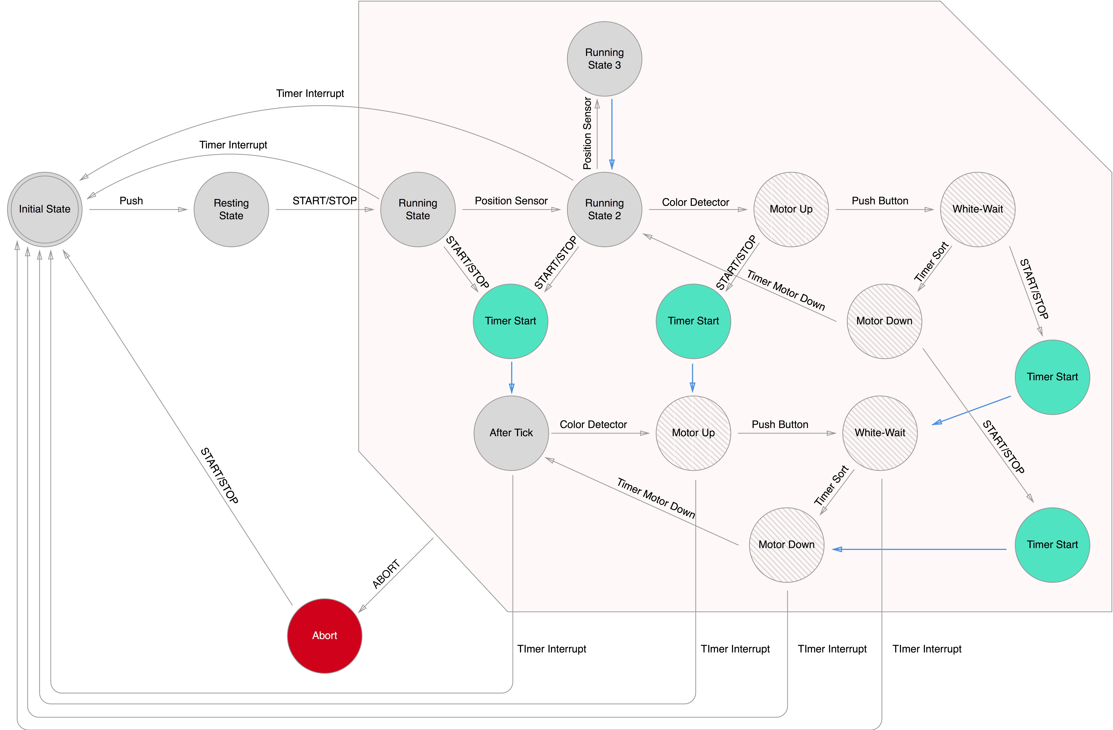
- Add state “Inital2” between “Initial” and “Resting”
- The position sensor does not trigger a state change when the input is 1, instead it does when the input is 0
- There are multiple states with the same name

UPPAAL model
[Insert UPPAAL model here]

Validation and Testing
[Insert validation and testing here]

